**Instructions for installing R program on your computer**

1. Using your preferred internet browser go to this website <http://www.r-project.org/>

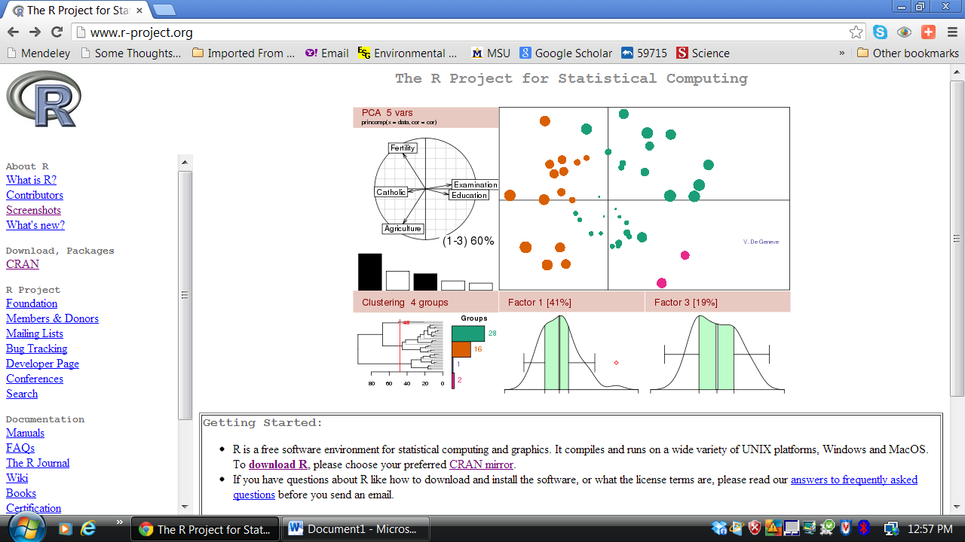

2. Click on the ‘CRAN’ link

3. Scroll down the page to the USA links and click on <http://cran.cnr.berkeley.edu/>

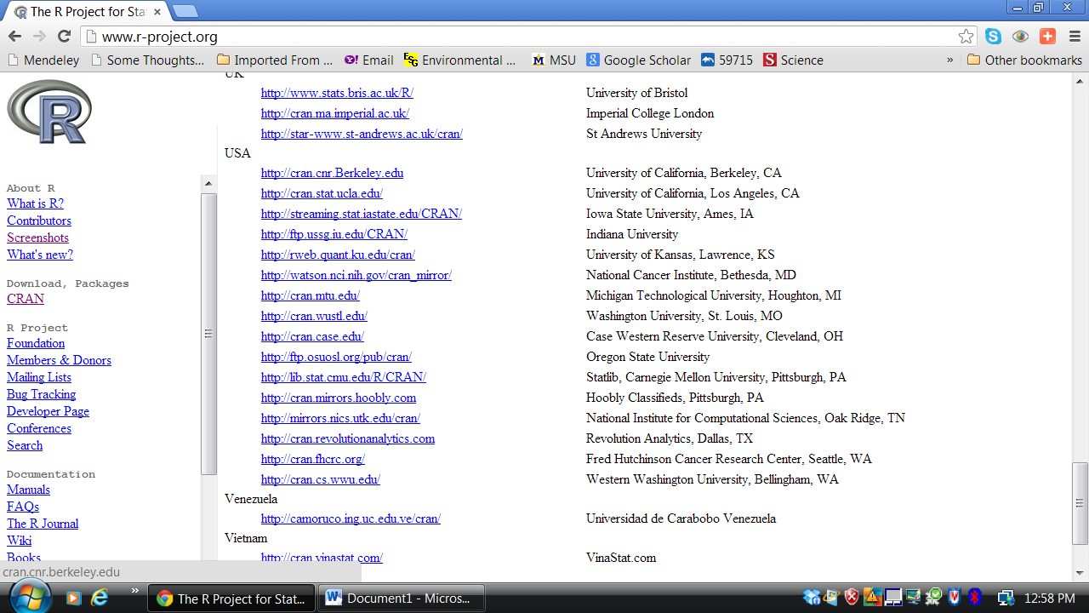

4. Next Click on the ‘Download R for Windows’ (Unless you have a Mac or run Linux on your computer then select the appropriate link for your operating system).

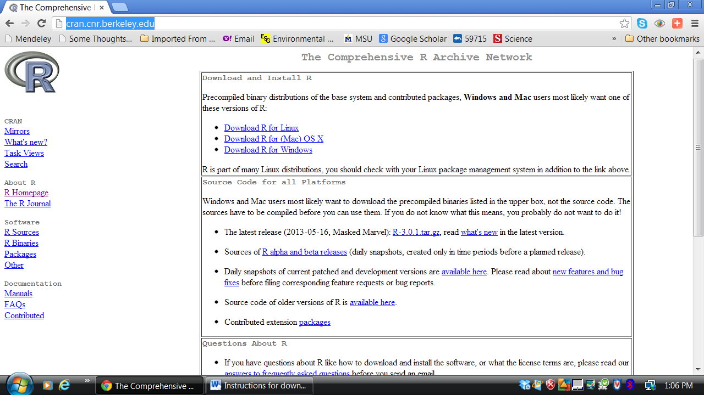

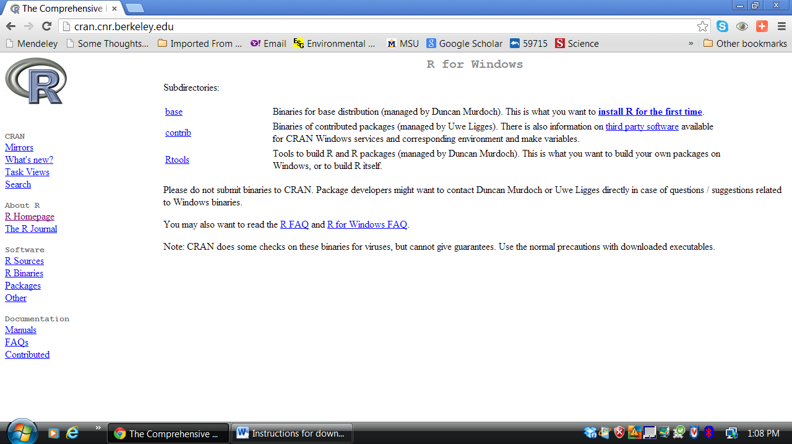

5. Click on the link ‘Install R for the first time’

6. Click on ‘Download R 3.0.01 for Windows’ link

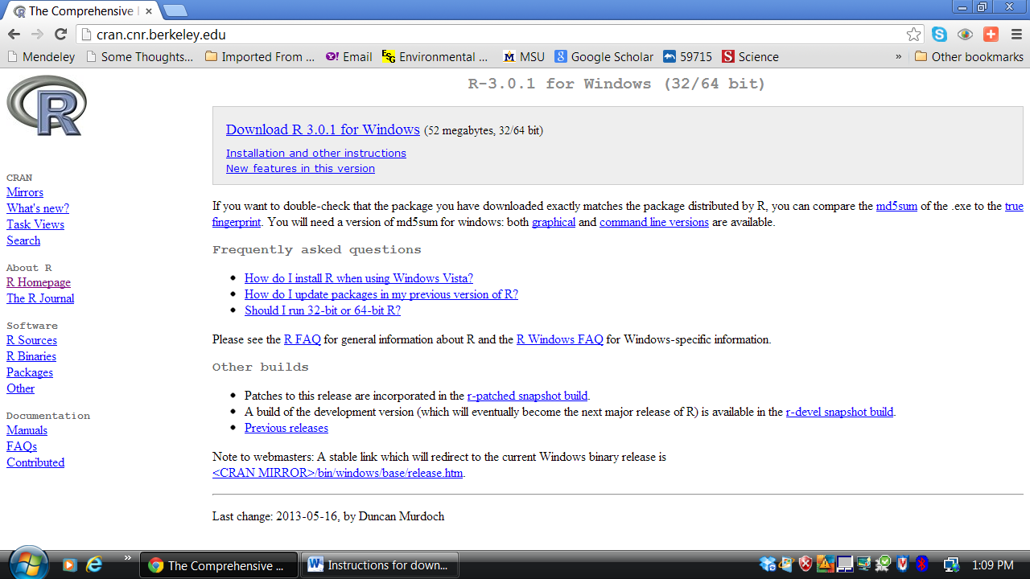

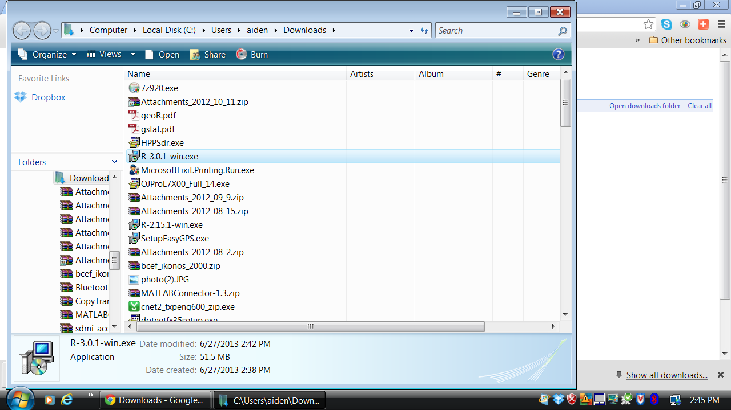7. Double click on ‘R-3.0.1-win.exe’. From the bottom of your internet browser window OR navigate to downloads folder in your file directory.

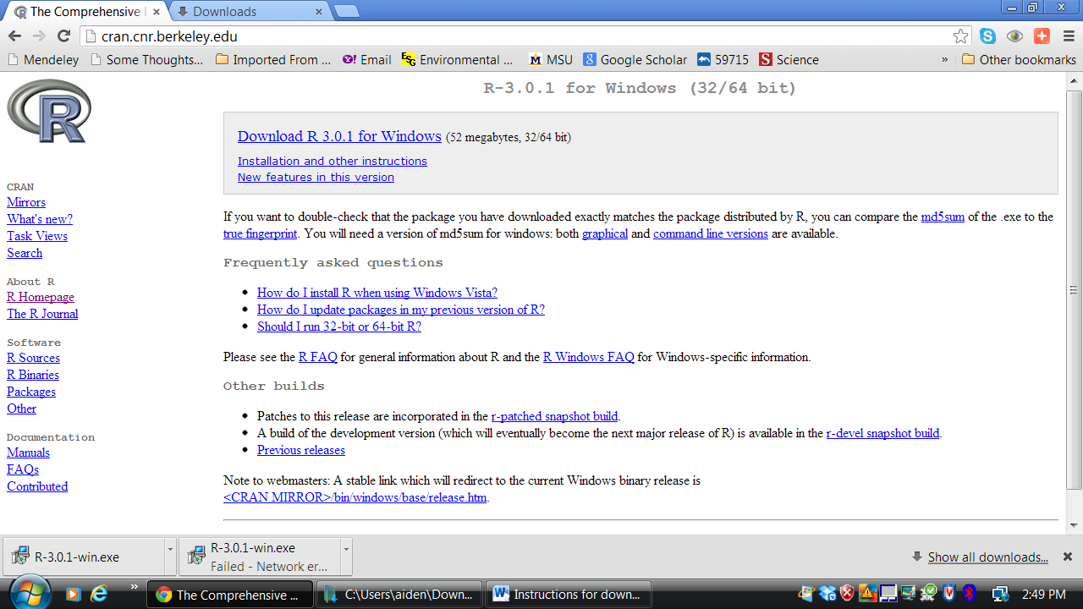

8. Click ‘Run’ in the Dialog box that appears after clicking on the .exe file

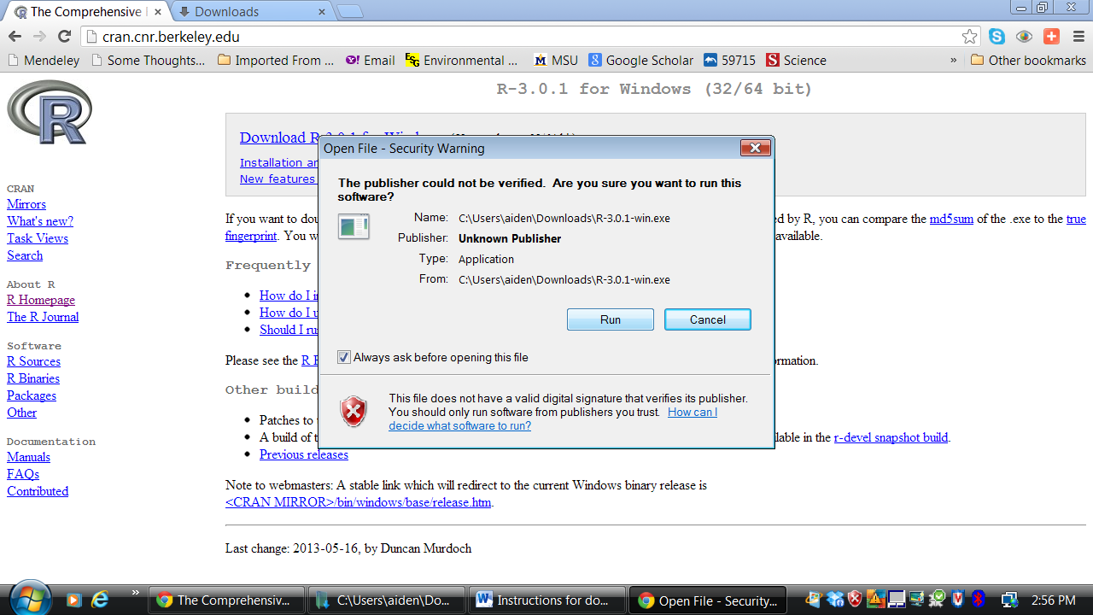9. Click ‘Next’ in the 3 following setup windows pictured below

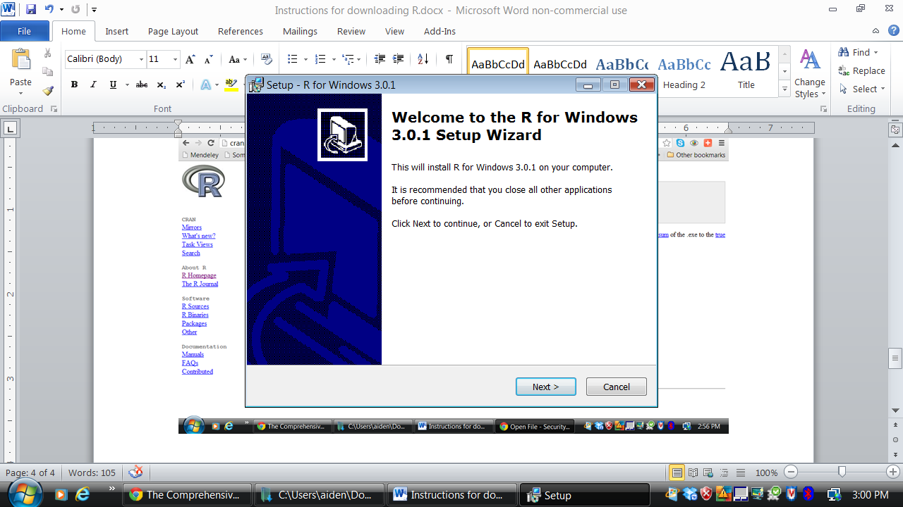

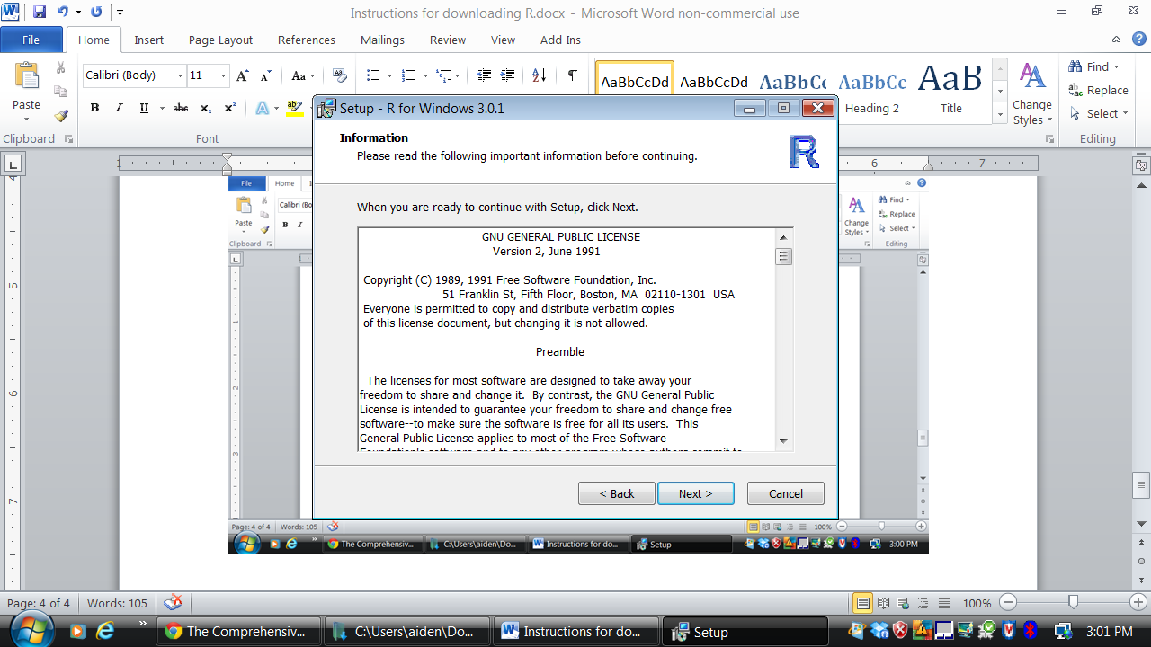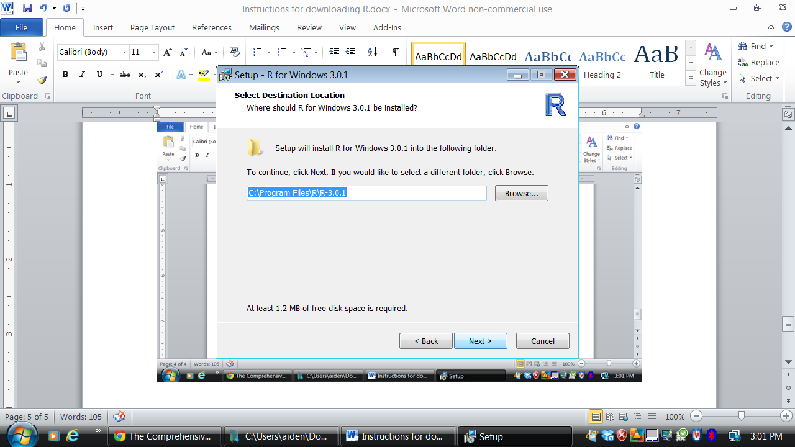

10. Select ‘Core Files’ and ’32-bit files’; unless you know you’re computer is 64bit. If you are certain you have a 64-bit machine unclick ’32-bit files’ and select the ’64-bit files’. You should have 2 things selected, and then click ‘Next’.

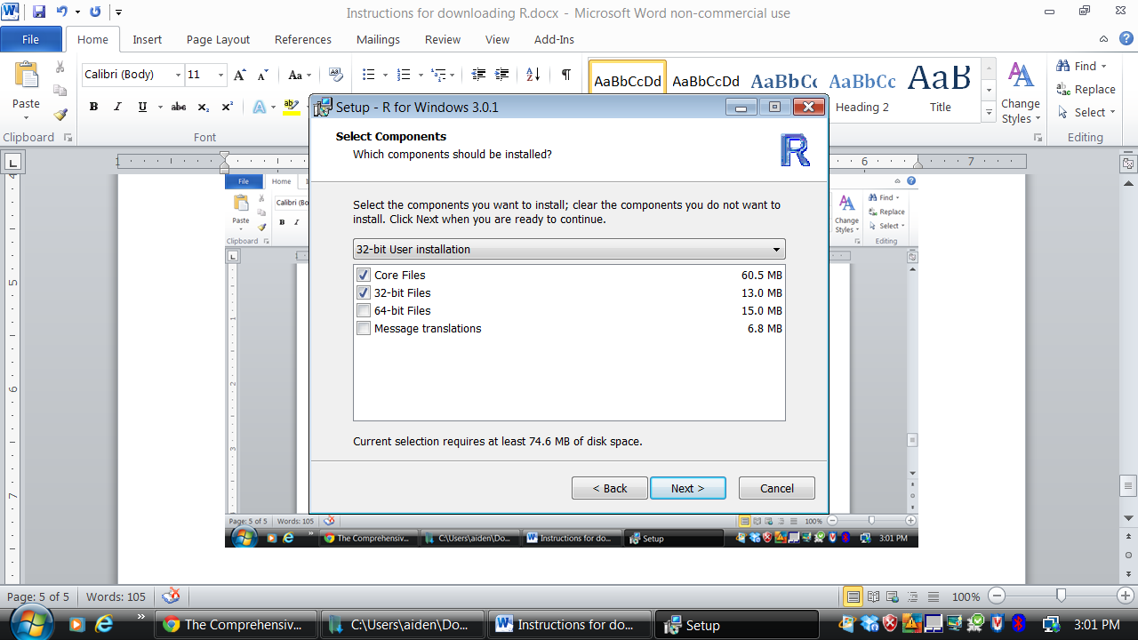

11. Click ‘Next’ with No selected in the Startup options dialog box.

12. Click ‘Next’ in the Start Menus Folder dialog box.

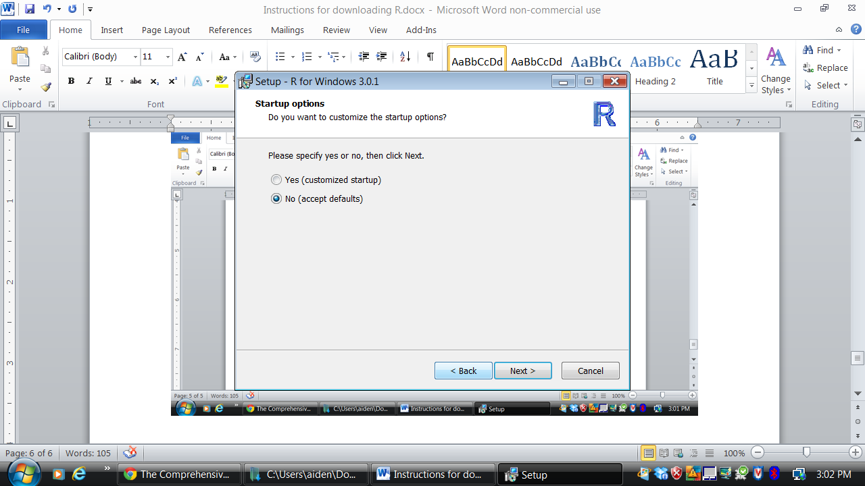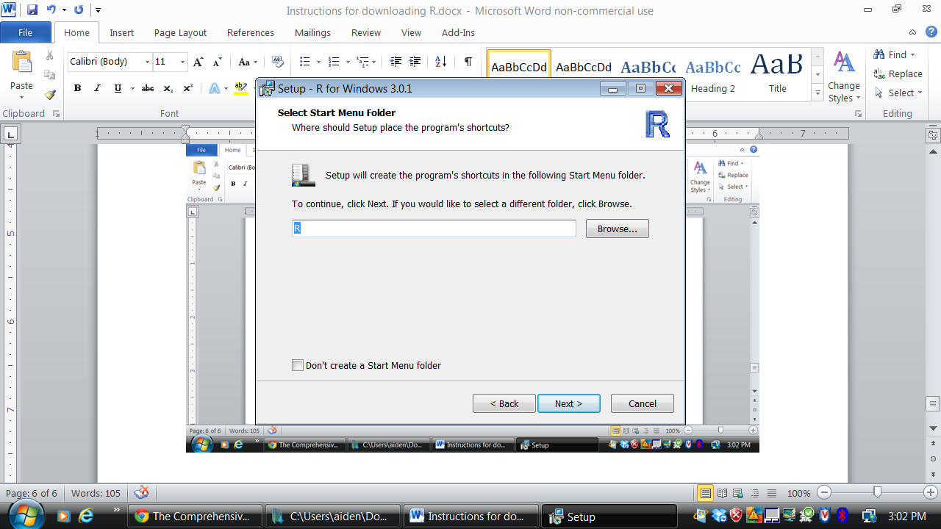

13. Click ‘Next’ in the Additional tasks dialog box

14. The program begins installing and you should see a progress bar.

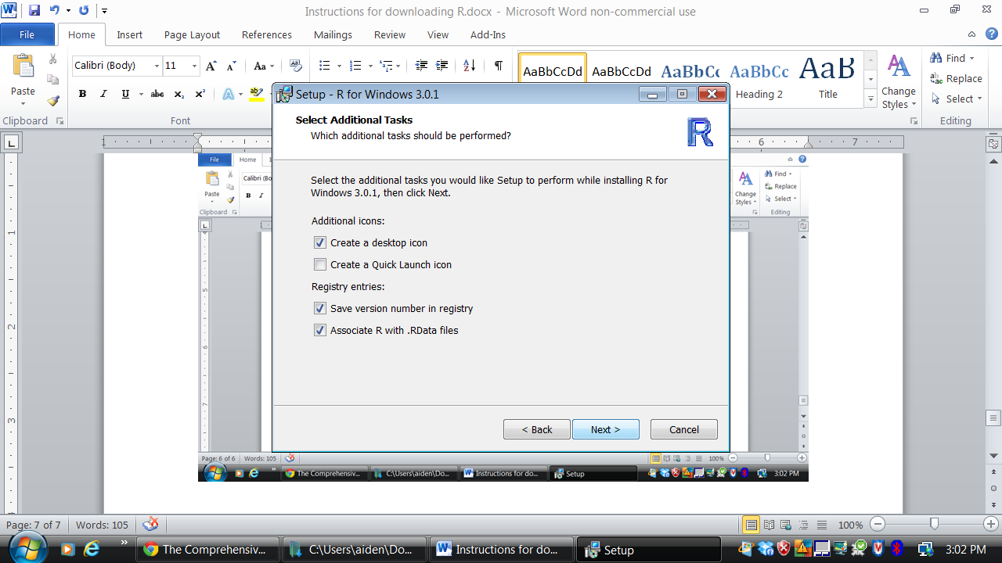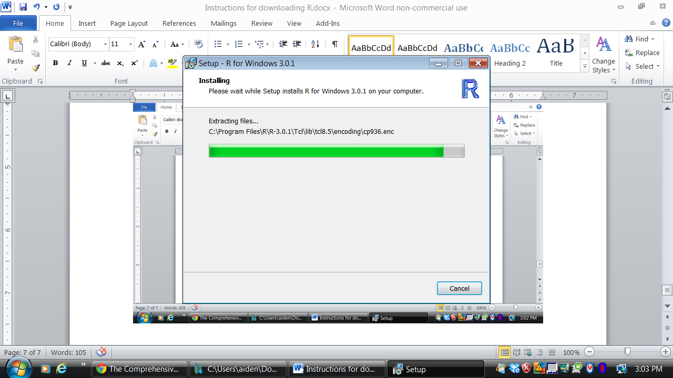

15. Once the installation is complete click ‘Finish’. And you’re done!!!!

